# Market Basket Analysis (MBA)

This repo contains the Market Basket Analysis (MBA) project as part of my data science portfolio. There are two parts in this project: 1. [Understanding MBA](#understanding-mba) 2. [Implementation in Python](#implementation-in-python)

The first part - Understanding MBA is for beginners who are new to this technique. It explains the theory, applications and workings of MBA with a case study of a supermarket. The second part - Implementation in Python contains the Python code to implement this technique using public dataset from [Kaggle](https://www.kaggle.com/). References are provided at the end of this project to give due credit to the authors of journal articles and resources that contributed to the completion of this project.

# Understanding MBA

Market basket analysis (MBA), also known as association-rule mining, is a useful method of discovering customer purchasing patterns by extracting associations or co-occurrences from stores' transactional databases (Chen et al., 2005). It is a modelling technique based upon the theory that if you buy a certain group of items, you are more (or less) likely to buy another group of items. For example, if you are in a supermarket and you buy a loaf of Bread, you are more likely to buy a packet of Butter at the same time than somebody who didn't buy the Bread. Another example, if you are buying a XiaoMi Power Bank in an online store, you are more likely to also buy a carrying case to go with the power bank. [Amazon](https://www.amazon.com/) knows this well from the transaction data of its millions of customers and thus recommends a case to you as seen below:

|  |
| --- |
| IMG_256 |

Credit: Amazon

The set of items a customer buys is known as an itemset, and MBA tries to identify relationships from the purchases of itemset. The output of MBA consists of a series of product association rules. From the transaction data extracted from the shopping carts of online retailers or the point of sales system of retail stores, we can use MBA to extract interesting association rules between products. For example, if customers buy product A they also tend to buy product B.

Typically we can extract the relationship between products in the form of a rule, an example of association rule:

IF {bread} THEN {butter}.

In this example, if customers buy Bread they also tend to buy Butter. Some people often link products with high association to "complementary goods". In Economics 101, complementary good or service is consumed or used in conjunction with another good or service. Usually, the complementary good has little to no value when consumed alone, but when combined with another good or service, it adds to the overall value of the offering. For example a car and petrol. It would be of little value to buy petrol without owning a car. Complementary goods often have a negative cross-price elasticity of demand coefficient (Farnham, 2014). However, it is worth pointing out that, while complementary goods tend to have high association, not all products with high association rules are complementary goods. In MBA, we are more interested in product-pairs with high association rules i.e. products that are frequently purchased together. For example, in a retail store, MBA findings may show that Barbie dolls and candy are frequently purchased together, even though they are not technically complementary goods. In short, complementary goods are fairly obvious and common sense, but MBA seeks to uncover product associations that may not be so obvious and straighforward. In doing so, it is attempting to convert the abstract consumer tastes and preferences into association rules that are more insightful and actionable, from business perspective.

## Applications

There are many real-life applications of MBA:

* ****Recommendation engine**** – showing related products as "Customers Who Bought This Item Also Bought" or “Frequently bought together” (as shown in the Amazon example above). It can also be applied to recommend videos and news article by analyzing the videos or news articles that are often watched or read together in a user session.

- \*\*Cross-sell / bundle products\*\* – selling associated products as a "bundle" instead of individual items. For example, transaction data may show that customers often buy a new phone with screen protector together. Phone retailers can then package new phone with high-margin screen protector together and sell them as a bundle, thereby increasing their sales.  
  
- \*\*Arrangement of items in retail stores\*\* – associated items can be placed closer to each other, thereby invoking "impulse buying". For example it may be uncovered that customers who buy Barbie dolls also buy candy at the same time. Thus retailers can place high-margin candy near Barbie doll display, thereby tempting customers to buy them together.  
  
- \*\*Detecting fraud\*\* – identifying related actions whenever a fraudulent transaction is performed. For example, in a fraudulent insurance claim for stolen vehicle, it may be analyzed (from historical data) that claimant frequently report the incident a few days late (action 1) and often refuse to cooperate with insurer on investigation (action 2). Insurers can identify these red flags once certain behaviours or actions are displayed by the claimants.

## Case Study

For simplicity we are analyzing only 2 items – Bread and Butter. We want to know if there is any evidence that suggests that buying Bread leads to buying Butter.

****Problem Statament:**** Is the purchase of Bread leads to the purchase of Butter?  
  
****Hypothesis:**** There is significant evidence to show that buying Bread leads to buying Butter.

Bread => Butter

Antecedent => Consequent

Let's take the example of a supermarket which generates 1,000 transactions monthly, of which Bread was purchased in 150 transactions, Butter in 130 transactions, and both together in 50 transactions.

In set theory it can be represented as Bread only – 100, Butter only – 80, Bread and Butter – 50, as shown in the Venn diagram below:

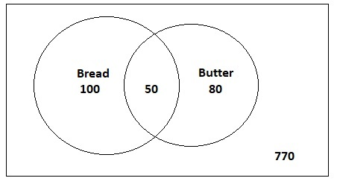

## Analysis and Findings

We can use MBA to extract the association rule between Bread and Butter. There are three metrics or criteria to evaluate the strength or quality of an association rule, which are support, confidence and lift.

### 1. Support

Support measures the percentage of transactions containing a particular combination of items relative to the total number of transactions. In our example, this is the percentage of transactions where both Bread and Butter are bought together. We need to calculate this to know if this combination of items is significant or negligible? Generally, we want a high percentage i.e. high support in order to make sure it is a useful relationship. Typically, we will set a threshold, for example we will only look at a combination if more than 1% of transactions have this combination.

Support (antecedent (Bread) and consequent (Butter)) = Number of transactions having both items / Total transactions

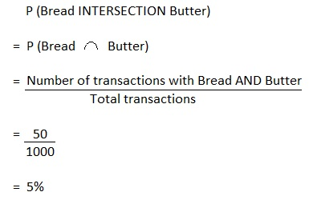

Result: The support value of 5% means 5% of all transactions have this combination of Bread and Butter bought together. Since the value is above the threshold of 1%, it shows there is indeed ***support*** for this association and thus satisfy the first criteria.

### 2. Confidence

Confidence measures the probability of finding a particular combination of items whenever antecedent is bought. In probability terms, confidence is the conditional probability of the consequent given the antecedent and is represented as P (consequent / antecedent). In our example, it is the probability of both Bread and Butter being bought together whenever Bread is bought. Typically, we may set a threshold, say we want this combination to occur at least 25% of times when Bread is bought.

Confidence (antecedent i.e. Bread and consequent i.e. Butter) = P (Consequent (Butter) is bought GIVEN antecedent (Bread) is bought)

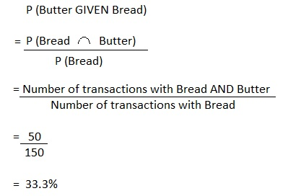

Result: The confidence value of 33.3% is above the threshold of 25%, indicating we can be ***confident*** that Butter will be bought whenever Bread is bought, and thus satisfy the second criteria.

### 3. Lift

Lift is a metric to determine how much the purchase of antecedent influences the purchase of consequent. In our example, we want to know whether the purchase of Butter is independent of the purchase of Bread (or) is the purchase of Butter happening due to the purchase of Bread? In probability terms, we want to know which is higher, P (Butter) or P (Butter / Bread)? If the purchase of Butter is influenced by the purchase of Bread, then P (Butter / Bread) will be higher than P (Butter), or in other words, the ratio of P (Butter / Bread) over P (Butter) will be higher than 1.

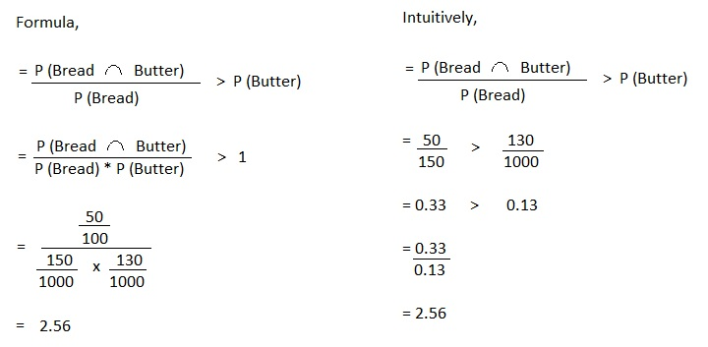

Result: The lift value of 2.56 is greater than 1, it shows that the purchase of Butter is indeed influenced by the purchase of Bread rather than Butter's purchase being independent of Bread. The lift value of 2.56 also means that Bread's purchase ***lifts*** the Butter's purchase by 2.56 times.

### Conclusion

Based on the findings above, we can justify our initial hypothesis as we

a) Have the support of 5% transactions for Bread and Butter in the same basket

b) Have 33.3% confidence that Butter sales happen whenever Bread is purchased.

c) Knows the lift in Butter's sales is 2.56 times more, whenever Bread is purchased than when Butter is purchased alone.

Therefore, we can conclude that there is indeed evidence to suggest that the purchase of Bread leads to the purchase of Butter. This is a valuable insight to guide management's decision-making. For example, managers of retail stores could start placing bread and butter close to each other, knowing that customers are highly likely to "impulsively" purchase them together, thereby increasing the store's revenue.

# Implementation in Python

While it is possible to use Ms Excel to calculate support, confidence and lifts, doing so on a large dataset with thousands of different combination of items can be a daunting task. Therefore, we will be resorting to Python libraries for a ready-made algorithm. Unfortunately, the popular scikit-learn library does not support this algorithm. Fortunately, we can use another library called [MLxtend (machine learning extensions)](http://rasbt.github.io/mlxtend/) by Sebastian Raschka which has an implementation of the ****Apriori**** algorithm for extracting frequent item sets for further analysis. [Chris Moffitt](http://pbpython.com/market-basket-analysis.html) has an awesome tutorial on using MLxtend which this project draws on.

If you are using Jupyter Notebook, the MLxtend library does not come pre-installed with Anaconda, but you can easily install this package with conda, just run one of the following in your Anaconda Prompt:  
  
conda install -c conda-forge mlxtend  
conda install -c conda-forge/label/gcc7 mlxtend

## Dataset

The [dataset](https://www.kaggle.com/xvivancos/transactions-from-a-bakery) that is used in this project is publicly available from Kaggle which contains the Transactions data from a bakery from 30/10/2016 to 09/04/2017. The data belongs to a bakery called "The Bread Basket" that serves coffee, bread, muffin, cookies and so on. It is located in the historic center of Edinburgh.

|  |
| --- |
| IMG_261 |

Credit: Kaggle

## Import libraries

In [1]:

*# import the libraries required***%matplotlib** inline**import** numpy **as** np **import** pandas **as** pd**import** matplotlib.pyplot **as** plt**from** mlxtend.frequent\_patterns **import** apriori**from** mlxtend.frequent\_patterns **import** association\_rules

## Load data

In [2]:

*# load the data into a pandas dataframe and take a look at the first 10 rows*bread **=** pd**.**read\_csv("BreadBasket\_DMS.csv")bread**.**head(10)

Out[2]:

|  | **Date** | **Time** | **Transaction** | **Item** |
| --- | --- | --- | --- | --- |
| **0** | 2016-10-30 | 09:58:11 | 1 | Bread |
| **1** | 2016-10-30 | 10:05:34 | 2 | Scandinavian |
| **2** | 2016-10-30 | 10:05:34 | 2 | Scandinavian |
| **3** | 2016-10-30 | 10:07:57 | 3 | Hot chocolate |
| **4** | 2016-10-30 | 10:07:57 | 3 | Jam |
| **5** | 2016-10-30 | 10:07:57 | 3 | Cookies |
| **6** | 2016-10-30 | 10:08:41 | 4 | Muffin |
| **7** | 2016-10-30 | 10:13:03 | 5 | Coffee |
| **8** | 2016-10-30 | 10:13:03 | 5 | Pastry |
| **9** | 2016-10-30 | 10:13:03 | 5 | Bread |

In [3]:

*# check the summary info of the dataframe*bread**.**info()

<class 'pandas.core.frame.DataFrame'>

RangeIndex: 21293 entries, 0 to 21292

Data columns (total 4 columns):

Date 21293 non-null object

Time 21293 non-null object

Transaction 21293 non-null int64

Item 21293 non-null object

dtypes: int64(1), object(3)

memory usage: 665.5+ KB

****Note:**** There are 21,293 rows and 4 columns in the dataframe. Date and Time columns are encoded in 'object' instead of Datetime, but fortunately there is a Transaction column which helps to identify each transaction. Item column contains the individual items in that transaction. For example, Transaction No. 3 contains items of "Hot chocolate", "Jam", and "Cookies" which are all transacted in the same time i.e 10.07.57 on 2016-10-30.

## Check for Missing Values

In [4]:

*# check for missing values*bread**.**isnull()**.**sum()

Out[4]:

Date 0

Time 0

Transaction 0

Item 0

dtype: int64

In [5]:

missing\_value **=** ["NaN", "NONE", "None", "Nil", "nan", "none", "nil", 0]print("There are {0} missing values in the dataframe."**.**format(len(bread[bread**.**Item**.**isin(missing\_value)])))bread[bread**.**Item**.**isin(missing\_value)]**.**head(10)

There are 786 missing values in the dataframe.

Out[5]:

|  | **Date** | **Time** | **Transaction** | **Item** |
| --- | --- | --- | --- | --- |
| **26** | 2016-10-30 | 10:27:21 | 11 | NONE |
| **38** | 2016-10-30 | 10:34:36 | 15 | NONE |
| **39** | 2016-10-30 | 10:34:36 | 15 | NONE |
| **66** | 2016-10-30 | 11:05:30 | 29 | NONE |
| **80** | 2016-10-30 | 11:37:10 | 37 | NONE |
| **85** | 2016-10-30 | 11:55:51 | 40 | NONE |
| **126** | 2016-10-30 | 13:02:04 | 59 | NONE |
| **140** | 2016-10-30 | 13:37:25 | 65 | NONE |
| **149** | 2016-10-30 | 13:46:48 | 67 | NONE |
| **167** | 2016-10-30 | 14:32:26 | 75 | NONE |

****Note:**** While there is no empty cell in the dataframe, a check using the popular missing value shows that there are 786 rows with "NONE" in the column Item. Since the items are not recorded, we will have to remove these rows.

In [6]:

bread **=** bread**.**drop(bread[bread**.**Item **==** "NONE"]**.**index)print("Number of rows: {0}"**.**format(len(bread)))bread**.**head(10)

Number of rows: 20507

Out[6]:

|  | **Date** | **Time** | **Transaction** | **Item** |
| --- | --- | --- | --- | --- |
| **0** | 2016-10-30 | 09:58:11 | 1 | Bread |
| **1** | 2016-10-30 | 10:05:34 | 2 | Scandinavian |
| **2** | 2016-10-30 | 10:05:34 | 2 | Scandinavian |
| **3** | 2016-10-30 | 10:07:57 | 3 | Hot chocolate |
| **4** | 2016-10-30 | 10:07:57 | 3 | Jam |
| **5** | 2016-10-30 | 10:07:57 | 3 | Cookies |
| **6** | 2016-10-30 | 10:08:41 | 4 | Muffin |
| **7** | 2016-10-30 | 10:13:03 | 5 | Coffee |
| **8** | 2016-10-30 | 10:13:03 | 5 | Pastry |
| **9** | 2016-10-30 | 10:13:03 | 5 | Bread |

****Note:**** After removing the missing values, the number of rows left is 20,507 (original 21,293 minus 786 missing)

## Convert to DatetimeIndex

In [7]:

bread['Datetime'] **=** pd**.**to\_datetime(bread['Date']**+**' '**+**bread['Time'])bread **=** bread[["Datetime", "Transaction", "Item"]]**.**set\_index("Datetime")bread**.**head(10)

Out[7]:

|  | **Transaction** | **Item** |
| --- | --- | --- |
| **Datetime** |  |  |
| **2016-10-30 09:58:11** | 1 | Bread |
| **2016-10-30 10:05:34** | 2 | Scandinavian |
| **2016-10-30 10:05:34** | 2 | Scandinavian |
| **2016-10-30 10:07:57** | 3 | Hot chocolate |
| **2016-10-30 10:07:57** | 3 | Jam |
| **2016-10-30 10:07:57** | 3 | Cookies |
| **2016-10-30 10:08:41** | 4 | Muffin |
| **2016-10-30 10:13:03** | 5 | Coffee |
| **2016-10-30 10:13:03** | 5 | Pastry |
| **2016-10-30 10:13:03** | 5 | Bread |

### Quick Stats

In [8]:

total\_items **=** len(bread)total\_days **=** len(np**.**unique(bread**.**index**.**date))total\_months **=** len(np**.**unique(bread**.**index**.**month))average\_items **=** total\_items **/** total\_daysunique\_items **=** bread**.**Item**.**unique()**.**size

print("There are {} unique items sold by the Bakery"**.**format(unique\_items))print("Total {} items sold in {} days throughout {} months"**.**format(total\_items, total\_days, total\_months))print("With an average of {} items sold daily"**.**format(average\_items))

There are 94 unique items sold by the Bakery

Total 20507 items sold in 159 days throughout 7 months

With an average of 128.9748427672956 items sold daily

****Note:**** We have combined the Date and Time columns into a single Datetime column, convert it into datetime64 type, and then set it as DatetimeIndex. This will make it easier to plot the time series charts later on. Also, a quick look at the data shows that the Bakery sold an average of 129 items daily.

## Visualization

In [9]:

*# rank the top 10 best-selling items*bread**.**Item**.**value\_counts(normalize**=True**)[:10]

Out[9]:

Coffee 0.266787

Bread 0.162140

Tea 0.069976

Cake 0.049983

Pastry 0.041742

Sandwich 0.037597

Medialuna 0.030039

Hot chocolate 0.028771

Cookies 0.026332

Brownie 0.018481

Name: Item, dtype: float64

In [10]:

*# create a bar chart, rank by percentage*bread**.**Item**.**value\_counts(normalize**=True**)[:10]**.**plot(kind**=**"bar", title**=**"Percentage of Sales by Item")**.**set(xlabel**=**"Item", ylabel**=**"Percentage")

Out[10]:

[Text(0,0.5,'Percentage'), Text(0.5,0,'Item')]

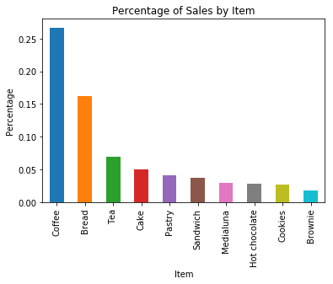

In [11]:

*# create a bar chart, rank by value*bread**.**Item**.**value\_counts()[:10]**.**plot(kind**=**"bar", title**=**"Total Number of Sales by Item")**.**set(xlabel**=**"Item", ylabel**=**"Total Number")

Out[11]:

[Text(0,0.5,'Total Number'), Text(0.5,0,'Item')]

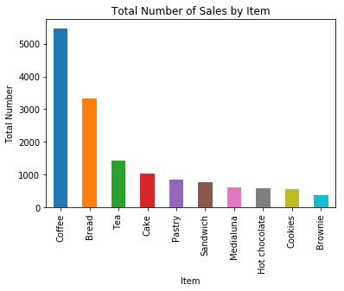

****Note:**** From the bar charts above, it is clear that Coffee (26.7%) is the best-selling item in the bakery, follow by Bread (16.2%) and Tea (7.0%).

In [12]:

*# plot time series chart of number of items by day*bread["Item"]**.**resample("D")**.**count()**.**plot(figsize**=**(12,5), grid**=True**, title**=**"Total Number of Items Sold by Date")**.**set(xlabel**=**"Date", ylabel**=**"Total Number of Items Sold")

Out[12]:

[Text(0,0.5,'Total Number of Items Sold'), Text(0.5,0,'Date')]

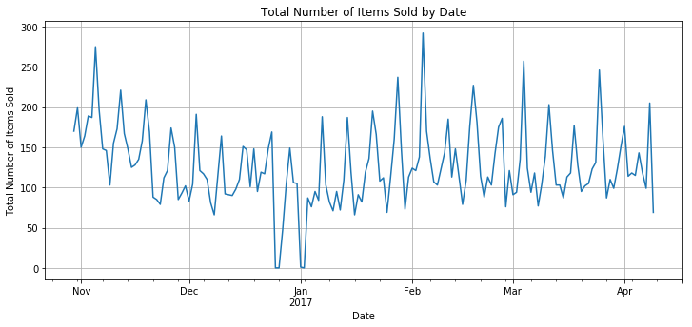

****Note:**** Total Number of Items Sold by Date fluctuates a lot thoughout the 159 days of data

In [13]:

bread["Item"]**.**resample("M")**.**count()

Out[13]:

Datetime

2016-10-31 369

2016-11-30 4436

2016-12-31 3339

2017-01-31 3356

2017-02-28 3906

2017-03-31 3944

2017-04-30 1157

Freq: M, Name: Item, dtype: int64

In [14]:

*# plot time series chart of number of items by month*bread["Item"]**.**resample("M")**.**count()**.**plot(figsize**=**(12,5), grid**=True**, title**=**"Total Number by Items Sold by Month")**.**set(xlabel**=**"Date", ylabel**=**"Total Number of Items Sold")

Out[14]:

[Text(0,0.5,'Total Number of Items Sold'), Text(0.5,0,'Date')]

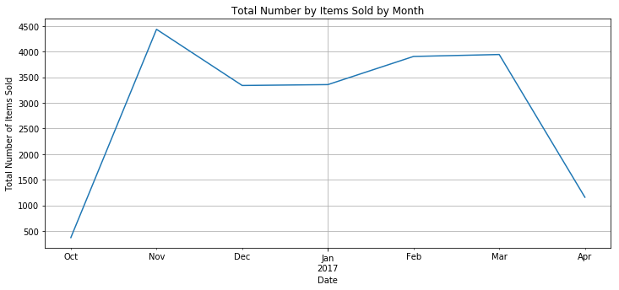

****Note:**** Given that the beginning month (October 2016) and ending month (April 2017) are not full month, the total number of items sold by month for the five full month between November 2016 to March 2017 does not fluctuate too much.

In [15]:

*# extract hour of the day and weekday of the week# For Datetimeindex, the day of the week with Monday=0, Sunday=6, thereby +1 to become Monday=1, Sunday=7*bread["Hour"] **=** bread**.**index**.**hourbread["Weekday"] **=** bread**.**index**.**weekday **+** 1

bread**.**head(10)

Out[15]:

|  | **Transaction** | **Item** | **Hour** | **Weekday** |
| --- | --- | --- | --- | --- |
| **Datetime** |  |  |  |  |
| **2016-10-30 09:58:11** | 1 | Bread | 9 | 7 |
| **2016-10-30 10:05:34** | 2 | Scandinavian | 10 | 7 |
| **2016-10-30 10:05:34** | 2 | Scandinavian | 10 | 7 |
| **2016-10-30 10:07:57** | 3 | Hot chocolate | 10 | 7 |
| **2016-10-30 10:07:57** | 3 | Jam | 10 | 7 |
| **2016-10-30 10:07:57** | 3 | Cookies | 10 | 7 |
| **2016-10-30 10:08:41** | 4 | Muffin | 10 | 7 |
| **2016-10-30 10:13:03** | 5 | Coffee | 10 | 7 |
| **2016-10-30 10:13:03** | 5 | Pastry | 10 | 7 |
| **2016-10-30 10:13:03** | 5 | Bread | 10 | 7 |

In [16]:

bread\_groupby\_hour **=** bread**.**groupby("Hour")**.**agg({"Item": **lambda** item: item**.**count()**/**total\_days})bread\_groupby\_hour

Out[16]:

|  | **Item** |
| --- | --- |
| **Hour** |  |
| **1** | 0.006289 |
| **7** | 0.150943 |
| **8** | 4.056604 |
| **9** | 12.364780 |
| **10** | 16.767296 |
| **11** | 19.509434 |
| **12** | 17.949686 |
| **13** | 16.459119 |
| **14** | 16.603774 |
| **15** | 13.301887 |
| **16** | 8.446541 |
| **17** | 2.314465 |
| **18** | 0.515723 |
| **19** | 0.301887 |
| **20** | 0.138365 |
| **21** | 0.018868 |
| **22** | 0.050314 |
| **23** | 0.018868 |

In [17]:

*# plot the chart*bread\_groupby\_hour**.**plot(y**=**"Item", figsize**=**(12,5), title**=**"Average Number by Items Sold by Hour of the Day")**.**set(xlabel**=**"Hour of the Day (24 hour time)", ylabel**=**"Average Number of Items Sold")

Out[17]:

[Text(0,0.5,'Average Number of Items Sold'),

Text(0.5,0,'Hour of the Day (24 hour time)')]

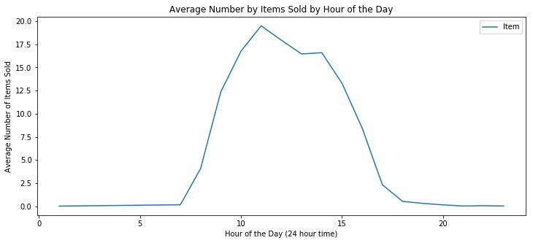

****Note:**** Sales starts to pick up from 8am, till the busiest hour of the day at 11am, then slowly drops till the late afternoon. It can be observed that most of the sales transactions took place during the lunch hours of the day

In [18]:

*# sales groupby weekday*bread\_groupby\_weekday **=** bread**.**groupby("Weekday")**.**agg({"Item": **lambda** item: item**.**count()})bread\_groupby\_weekday

Out[18]:

|  | **Item** |
| --- | --- |
| **Weekday** |  |
| **1** | 2324 |
| **2** | 2392 |
| **3** | 2321 |
| **4** | 2646 |
| **5** | 3124 |
| **6** | 4605 |
| **7** | 3095 |

In [19]:

*# but we need to find out how many each weekday in that period of transaction# in order to calculate the average items per weekday*

**import** datetime daterange **=** pd**.**date\_range(datetime**.**date(2016, 10, 30), datetime**.**date(2017, 4, 9))

monday **=** 0tuesday **=** 0wednesday **=** 0thursday **=** 0friday **=** 0saturday **=** 0sunday **=** 0

**for** day **in** np**.**unique(bread**.**index**.**date):

**if** day**.**isoweekday() **==** 1:

monday **+=** 1

**elif** day**.**isoweekday() **==** 2:

tuesday **+=** 1

**elif** day**.**isoweekday() **==** 3:

wednesday **+=** 1

**elif** day**.**isoweekday() **==** 4:

thursday **+=** 1

**elif** day**.**isoweekday() **==** 5:

friday **+=** 1

**elif** day**.**isoweekday() **==** 6:

saturday **+=** 1

**elif** day**.**isoweekday() **==** 7:

sunday **+=** 1

all\_weekdays **=** monday **+** tuesday **+** wednesday **+** thursday **+** friday **+** saturday **+** sunday

print("monday = {0}, tuesday = {1}, wednesday = {2}, thursday = {3}, friday = {4}, saturday = {5}, sunday = {6}, total = {7}"**.**format(monday, tuesday, wednesday, thursday, friday, saturday, sunday, all\_weekdays))

monday = 21, tuesday = 23, wednesday = 23, thursday = 23, friday = 23, saturday = 23, sunday = 23, total = 159

In [20]:

*# apply the conditions to calculate the average items for each weekday*conditions **=** [

(bread\_groupby\_weekday**.**index **==** 1),

(bread\_groupby\_weekday**.**index **==** 2),

(bread\_groupby\_weekday**.**index **==** 3),

(bread\_groupby\_weekday**.**index **==** 4),

(bread\_groupby\_weekday**.**index **==** 5),

(bread\_groupby\_weekday**.**index **==** 6),

(bread\_groupby\_weekday**.**index **==** 7)]

choices **=** [bread\_groupby\_weekday**.**Item**/**21, bread\_groupby\_weekday**.**Item**/**23, bread\_groupby\_weekday**.**Item**/**23, bread\_groupby\_weekday**.**Item**/**23, bread\_groupby\_weekday**.**Item**/**23, bread\_groupby\_weekday**.**Item**/**23, bread\_groupby\_weekday**.**Item**/**23]

bread\_groupby\_weekday["Average"] **=** np**.**select(conditions, choices, default**=**0)bread\_groupby\_weekday

Out[20]:

|  | **Item** | **Average** |
| --- | --- | --- |
| **Weekday** |  |  |
| **1** | 2324 | 110.666667 |
| **2** | 2392 | 104.000000 |
| **3** | 2321 | 100.913043 |
| **4** | 2646 | 115.043478 |
| **5** | 3124 | 135.826087 |
| **6** | 4605 | 200.217391 |
| **7** | 3095 | 134.565217 |

In [21]:

bread\_groupby\_weekday**.**plot(y**=**"Average", figsize**=**(12,5), title**=**"Average Number by Items Sold by Day of the Week")**.**set(xlabel**=**"Day of the Week (1=Monday, 7=Sunday)", ylabel**=**"Average Number of Items Sold")

Out[21]:

[Text(0,0.5,'Average Number of Items Sold'),

Text(0.5,0,'Day of the Week (1=Monday, 7=Sunday)')]

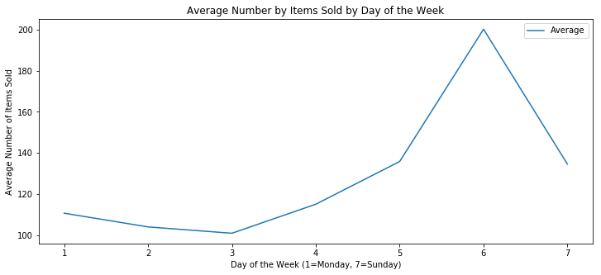

****Note:**** Saturday is the busiest day of the week with the highest sales (~200 items) while Wednesday is the quietest day with the lowest sales (~101 items). This is an interesting insight, the owner of the Bakery should launch some promotion activities to boost up sales in the middle of the week when sales are slowest.

## One-Hot Encoding

The ****Apriori**** function in the MLxtend library expects data in a one-hot encoded pandas DataFrame. This means that all the data for a transaction must be included in one row and the items must be one-hot encoded. Example below:

|  | **Coffee** | **Cake** | **Bread** | **Cookie** | **Muffin** | **Tea** | **Milk** | **Juice** | **Sandwich** |
| --- | --- | --- | --- | --- | --- | --- | --- | --- | --- |
| 0 | 0 | 1 | 1 | 0 | 0 | 0 | 0 | 1 | 0 |
| 1 | 1 | 0 | 0 | 0 | 1 | 0 | 0 | 0 | 0 |
| 2 | 0 | 0 | 0 | 1 | 0 | 0 | 0 | 0 | 1 |
| 3 | 1 | 0 | 0 | 0 | 0 | 1 | 0 | 0 | 1 |
| 4 | 1 | 1 | 0 | 0 | 0 | 0 | 0 | 0 | 0 |

Therefore, we'll need to group the bread dataframe by Transaction and Item and display the count of items. Then we need to consolidate the items into one transaction per row with each item one-hot encoded.

In [22]:

df **=** bread**.**groupby(["Transaction","Item"])**.**size()**.**reset\_index(name**=**"Count")

df**.**head()

Out[22]:

|  | **Transaction** | **Item** | **Count** |
| --- | --- | --- | --- |
| **0** | 1 | Bread | 1 |
| **1** | 2 | Scandinavian | 2 |
| **2** | 3 | Cookies | 1 |
| **3** | 3 | Hot chocolate | 1 |
| **4** | 3 | Jam | 1 |

In [23]:

basket **=** (df**.**groupby(['Transaction', 'Item'])['Count']

**.**sum()**.**unstack()**.**reset\_index()**.**fillna(0)

**.**set\_index('Transaction'))

basket**.**head()

Out[23]:

| **Item** | **Adjustment** | **Afternoon with the baker** | **Alfajores** | **Argentina Night** | **Art Tray** | **Bacon** | **Baguette** | **Bakewell** | **Bare Popcorn** | **Basket** | **...** | **The BART** | **The Nomad** | **Tiffin** | **Toast** | **Truffles** | **Tshirt** | **Valentine's card** | **Vegan Feast** | **Vegan mincepie** | **Victorian Sponge** |
| --- | --- | --- | --- | --- | --- | --- | --- | --- | --- | --- | --- | --- | --- | --- | --- | --- | --- | --- | --- | --- | --- |
| **Transaction** |  |  |  |  |  |  |  |  |  |  |  |  |  |  |  |  |  |  |  |  |  |
| **1** | 0.0 | 0.0 | 0.0 | 0.0 | 0.0 | 0.0 | 0.0 | 0.0 | 0.0 | 0.0 | ... | 0.0 | 0.0 | 0.0 | 0.0 | 0.0 | 0.0 | 0.0 | 0.0 | 0.0 | 0.0 |
| **2** | 0.0 | 0.0 | 0.0 | 0.0 | 0.0 | 0.0 | 0.0 | 0.0 | 0.0 | 0.0 | ... | 0.0 | 0.0 | 0.0 | 0.0 | 0.0 | 0.0 | 0.0 | 0.0 | 0.0 | 0.0 |
| **3** | 0.0 | 0.0 | 0.0 | 0.0 | 0.0 | 0.0 | 0.0 | 0.0 | 0.0 | 0.0 | ... | 0.0 | 0.0 | 0.0 | 0.0 | 0.0 | 0.0 | 0.0 | 0.0 | 0.0 | 0.0 |
| **4** | 0.0 | 0.0 | 0.0 | 0.0 | 0.0 | 0.0 | 0.0 | 0.0 | 0.0 | 0.0 | ... | 0.0 | 0.0 | 0.0 | 0.0 | 0.0 | 0.0 | 0.0 | 0.0 | 0.0 | 0.0 |
| **5** | 0.0 | 0.0 | 0.0 | 0.0 | 0.0 | 0.0 | 0.0 | 0.0 | 0.0 | 0.0 | ... | 0.0 | 0.0 | 0.0 | 0.0 | 0.0 | 0.0 | 0.0 | 0.0 | 0.0 | 0.0 |

5 rows × 94 columns

In [24]:

basket[basket**.**Coffee **==** 4]**.**iloc[:,14:28]

Out[24]:

| **Item** | **Brownie** | **Cake** | **Caramel bites** | **Cherry me Dried fruit** | **Chicken Stew** | **Chicken sand** | **Chimichurri Oil** | **Chocolates** | **Christmas common** | **Coffee** | **Coffee granules** | **Coke** | **Cookies** | **Crepes** |
| --- | --- | --- | --- | --- | --- | --- | --- | --- | --- | --- | --- | --- | --- | --- |
| **Transaction** |  |  |  |  |  |  |  |  |  |  |  |  |  |  |
| **6560** | 0.0 | 0.0 | 0.0 | 0.0 | 0.0 | 0.0 | 0.0 | 0.0 | 0.0 | 4.0 | 0.0 | 0.0 | 1.0 | 0.0 |
| **6850** | 0.0 | 0.0 | 0.0 | 0.0 | 0.0 | 0.0 | 0.0 | 0.0 | 0.0 | 4.0 | 0.0 | 0.0 | 0.0 | 0.0 |
| **6887** | 0.0 | 1.0 | 0.0 | 0.0 | 0.0 | 0.0 | 0.0 | 0.0 | 0.0 | 4.0 | 0.0 | 0.0 | 0.0 | 0.0 |

****Note:**** At this stage, the one-hot encoded table shows the count of items purchased as result. If you observe the portion of the table above, in Transaction 6887, the cell value for Coffee is "4.0" because there were 4 coffee purchased in this transaction. However, this is not important for us and we need to convert this value into 1.

In [25]:

*# the encoding function***def** encode\_units(x):

**if** x **<=** 0:

**return** 0

**if** x **>=** 1:

**return** 1

In [26]:

basket\_sets **=** basket**.**applymap(encode\_units)

basket\_sets**.**head()

Out[26]:

| **Item** | **Adjustment** | **Afternoon with the baker** | **Alfajores** | **Argentina Night** | **Art Tray** | **Bacon** | **Baguette** | **Bakewell** | **Bare Popcorn** | **Basket** | **...** | **The BART** | **The Nomad** | **Tiffin** | **Toast** | **Truffles** | **Tshirt** | **Valentine's card** | **Vegan Feast** | **Vegan mincepie** | **Victorian Sponge** |
| --- | --- | --- | --- | --- | --- | --- | --- | --- | --- | --- | --- | --- | --- | --- | --- | --- | --- | --- | --- | --- | --- |
| **Transaction** |  |  |  |  |  |  |  |  |  |  |  |  |  |  |  |  |  |  |  |  |  |
| **1** | 0 | 0 | 0 | 0 | 0 | 0 | 0 | 0 | 0 | 0 | ... | 0 | 0 | 0 | 0 | 0 | 0 | 0 | 0 | 0 | 0 |
| **2** | 0 | 0 | 0 | 0 | 0 | 0 | 0 | 0 | 0 | 0 | ... | 0 | 0 | 0 | 0 | 0 | 0 | 0 | 0 | 0 | 0 |
| **3** | 0 | 0 | 0 | 0 | 0 | 0 | 0 | 0 | 0 | 0 | ... | 0 | 0 | 0 | 0 | 0 | 0 | 0 | 0 | 0 | 0 |
| **4** | 0 | 0 | 0 | 0 | 0 | 0 | 0 | 0 | 0 | 0 | ... | 0 | 0 | 0 | 0 | 0 | 0 | 0 | 0 | 0 | 0 |
| **5** | 0 | 0 | 0 | 0 | 0 | 0 | 0 | 0 | 0 | 0 | ... | 0 | 0 | 0 | 0 | 0 | 0 | 0 | 0 | 0 | 0 |

5 rows × 94 columns

In [27]:

basket\_sets[basket\_sets**.**Coffee **==** 1]**.**iloc[3142:3145,14:28]

Out[27]:

| **Item** | **Brownie** | **Cake** | **Caramel bites** | **Cherry me Dried fruit** | **Chicken Stew** | **Chicken sand** | **Chimichurri Oil** | **Chocolates** | **Christmas common** | **Coffee** | **Coffee granules** | **Coke** | **Cookies** | **Crepes** |
| --- | --- | --- | --- | --- | --- | --- | --- | --- | --- | --- | --- | --- | --- | --- |
| **Transaction** |  |  |  |  |  |  |  |  |  |  |  |  |  |  |
| **6884** | 0 | 0 | 0 | 0 | 0 | 0 | 0 | 0 | 0 | 1 | 0 | 0 | 0 | 0 |
| **6885** | 1 | 0 | 0 | 0 | 0 | 0 | 0 | 0 | 0 | 1 | 0 | 0 | 0 | 0 |
| **6887** | 0 | 1 | 0 | 0 | 0 | 0 | 0 | 0 | 0 | 1 | 0 | 0 | 0 | 0 |

****Note:**** After applying the encoding function, for the same Transaction 6887, the cell value for Coffee has become "1" which is what we need for the ****Apriori**** function.

## Generate Frequent Itemsets

Now, we are ready to generate the frequent item sets. We will set the minimum-support threshold at 1%

In [28]:

frequent\_itemsets **=** apriori(basket\_sets, min\_support**=**0.01, use\_colnames**=True**)

## Generate Association Rules

The final step is to generate the rules with their corresponding support, confidence and lift. We will set the minimum threshold for lift at 1 and then sort the result by descending confidence value.

In [29]:

rules **=** association\_rules(frequent\_itemsets, metric**=**"lift", min\_threshold**=**1)rules**.**sort\_values("confidence", ascending **=** **False**, inplace **=** **True**)rules**.**head(10)

Out[29]:

|  | **antecedents** | **consequents** | **antecedent support** | **consequent support** | **support** | **confidence** | **lift** | **leverage** | **conviction** |
| --- | --- | --- | --- | --- | --- | --- | --- | --- | --- |
| **31** | (Toast) | (Coffee) | 0.033597 | 0.478394 | 0.023666 | 0.704403 | 1.472431 | 0.007593 | 1.764582 |
| **29** | (Spanish Brunch) | (Coffee) | 0.018172 | 0.478394 | 0.010882 | 0.598837 | 1.251766 | 0.002189 | 1.300235 |
| **19** | (Medialuna) | (Coffee) | 0.061807 | 0.478394 | 0.035182 | 0.569231 | 1.189878 | 0.005614 | 1.210871 |
| **23** | (Pastry) | (Coffee) | 0.086107 | 0.478394 | 0.047544 | 0.552147 | 1.154168 | 0.006351 | 1.164682 |
| **1** | (Alfajores) | (Coffee) | 0.036344 | 0.478394 | 0.019651 | 0.540698 | 1.130235 | 0.002264 | 1.135648 |
| **16** | (Juice) | (Coffee) | 0.038563 | 0.478394 | 0.020602 | 0.534247 | 1.116750 | 0.002154 | 1.119919 |
| **25** | (Sandwich) | (Coffee) | 0.071844 | 0.478394 | 0.038246 | 0.532353 | 1.112792 | 0.003877 | 1.115384 |
| **7** | (Cake) | (Coffee) | 0.103856 | 0.478394 | 0.054728 | 0.526958 | 1.101515 | 0.005044 | 1.102664 |
| **27** | (Scone) | (Coffee) | 0.034548 | 0.478394 | 0.018067 | 0.522936 | 1.093107 | 0.001539 | 1.093366 |
| **12** | (Cookies) | (Coffee) | 0.054411 | 0.478394 | 0.028209 | 0.518447 | 1.083723 | 0.002179 | 1.083174 |

## Interpretation and Implications

The output above shows the Top 10 itemsets sorted by confidence value and all itemsets have support value over 1% and lift value over 1. The first itemset shows the association rule "if Toast then Coffee" with support value at 0.023666 means nearly 2.4% of all transactions have this combination of Toast and Coffee bought together. We also have 70% confidence that Coffee sales happen whenever a Toast is purchased. The lift value of 1.47 (greater than 1) shows that the purchase of Coffee is indeed influenced by the purchase of Toast rather than Coffee's purchase being independent of Toast. The lift value of 1.47 means that Toast's purchase lifts the Coffee's purchase by 1.47 times.

Therefore, we can conclude that there is indeed evidence to suggest that the purchase of Toast leads to the purchase of Coffee. The owner of the bakery "The Bread Basket" should consider bundling Toast and Cofee together as a Breakfast Set or Lunch Set, the staff in the store should also be trained to cross-sell Coffee to customers who purchase Toast, knowing that they are more likely to purchase them together, thereby increasing the store's revenue.